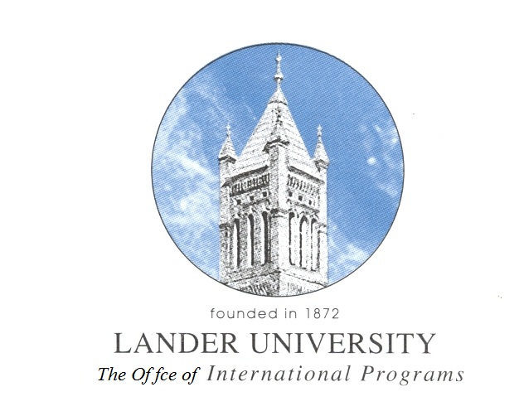
Application

Type of Programs you are applying for:

2013 ASIA SUMMER STUDY PROGRAM TO CHINA & KOREA ( )
2013 THAILAND SUMMER ENGLISH CAMP LEADERS ( )
2013 SEMETSER EXCHANGE PROGRAM AT UNIVERSITY OF INCHEON ( )

Date: ________________________

Full Name: ___________________________________________________________________

L number: _______________________

Address: _____________________________________________________________________

Campus Phone: ________________________ Home Phone: ____________________________

Check one:
( ) Faculty Dept: ______________________ Years in Service: _________________

( ) Student: Major: ______________________________________________________

( ) Fresh. ( ) Soph. ( ) Jr. ( ) Sr. ( ) Grad Student: GPA _______

Submit The Following Documents Along With This Application:

- Statement of purpose: indicating the reason for wanting to participate and the expected benefits from the summer study program.

- A recent resume (Curriculum Vitae)

- A letters of recommendation:
- Student - at least one from a professor
- Faculty - one from your department head

Send to: To: Ms. Boyoung Roh
Office of International Programs Visit us at:
Jackson Library 300 http://international.lander.edu
Phone: 388-8646
broh@lander.edu

